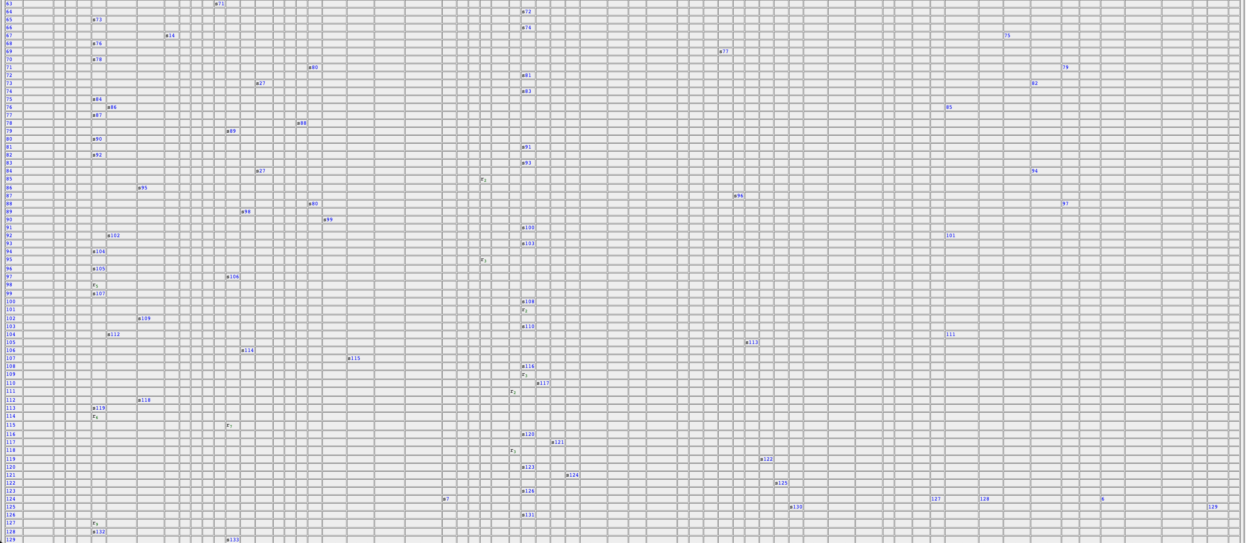

Strings that parse

Strings that do NOT parse

GRAMMAR RULES

<start> -> `lecture` <block>

<block> -> `{` <stmt> `}` $<end> $ indicating that the block should end with the end statement

<stmt> -> <assignment> | <looping> | <addminus> | <muldivmod>

<assignment> -> `$`<factor> <ident>`;`

<looping> -> <ha_stmt> | <during_stmt>

<addminus> -> `$$` <ident> { (+ | - | =) <ident> } `;`

<muldivmod> -> `$$$` <ident> { (* | / | %) <ident> } `;`

<ident> -> 'id' | 'digit' | 'letter'

<factor> -> 'int_lit' | 'float_int'

<ha_stmt> -> `ha` `(` <bool_expr> `)` <stmt> [ `lol` <stmt> ] ha = if stmt

<during_stmt> -> `during` `(` <bool_expr> `)` <stmt> during = while stmt

<bool_expr> -> <b_eq>

<b_eq> -> [!]<b_fact> { ( `==` | `!=` | `<=` | `<` | `>=` | `>` ) <b_fact> }

<b_fact> -> `id` | `digit` | `letter`

<end> -> `hahaha`